**16-BIT SUBTRACTION:**

**EXP NO:6**

**AIM:**To write an assembly language program to implement 16-bit addition using an 8085 processor.

**APPARATUS:** GNUSim8085

**ALGORITHM:**

1)Start the program by loading a register pair with the address of 1st number.  
2) Copy the data to another register pair.  
3) Load the second number to the first register pair.  
4) Subtract the two register pair contents.  
5) Check for borrowing.  
6) Store the value of the difference and borrow it in memory locations.  
7) End

**PROGRAM:**

 LHLD 2050  
 XCHG  
 LHLD 2052  
 MVI C,00  
 MOV A, E  
 SUB L  
 STA 2054  
 MOV A, D  
 SUB H  
 STA 2055  
  HLT

**INPUT:**

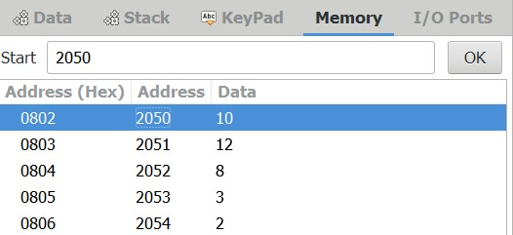

**OUTPUT:**

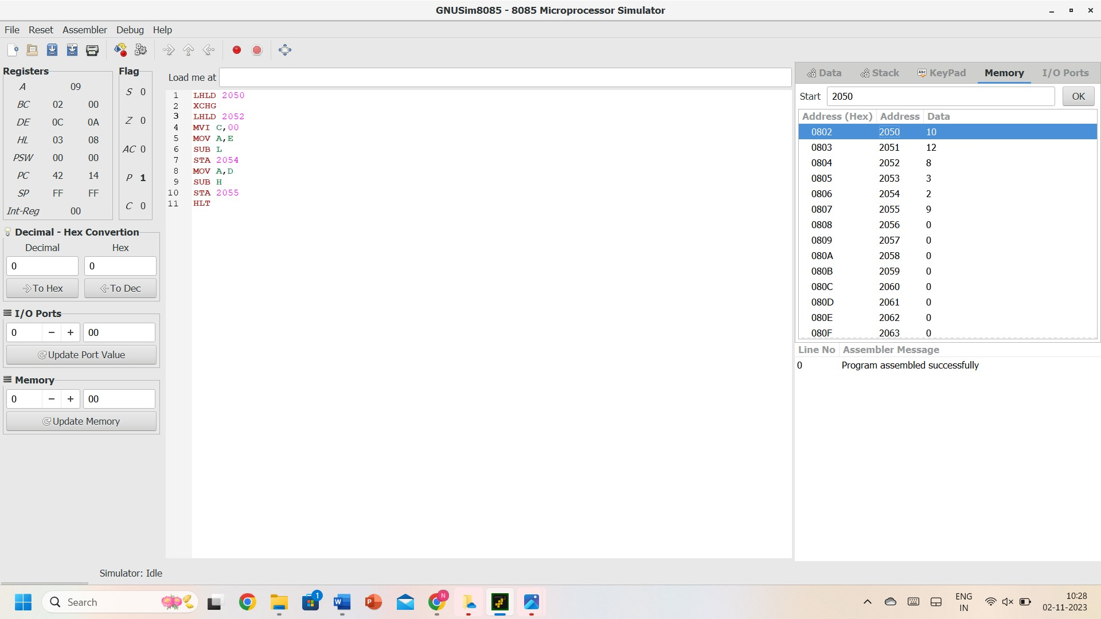

**RESULT:** Thus, the program was executed successfully using 8085 processor simulators.